iRevolution – A Data-driven Exploration of Apple’s iPhone Impact in India using Tableau

1. INTRODUCTION
1.1 Project Overview
The iRevolution project focuses on analyzing and visualizing the impact of Apple’s iPhone in the Indian smartphone market using data visualization techniques. The project leverages Tableau to transform raw market data into meaningful visual insights that help understand trends in sales, pricing, market share, and consumer adoption across India.
1.2 Purpose
The purpose of this project is to provide a data-driven understanding of how iPhones have influenced the Indian smartphone ecosystem. By using interactive dashboards, the project aims to support students, analysts, and decision-makers in interpreting complex datasets easily and effectively.

2. IDEATION PHASE
2.1 Problem Statement
Understanding the impact of premium smartphones like the iPhone in India is challenging due to scattered, complex, and large datasets. Traditional analysis methods make it difficult to identify trends, correlations, and insights. This project addresses the problem by using Tableau to visually analyze and present iPhone-related market data in a clear and interactive manner.
2.2 Empathy Map Canvas
- Think & Feel: Needs accurate insights, feels pressure to present reliable data, worries about missing trends.
- Hear: Experts emphasize data visualization, peers suggest dashboards, industry talks about premium phone growth.
- See: Large raw datasets, complex reports, visual dashboards.
- Say & Do: Builds dashboards, analyzes trends, presents insights.
- Pain: Data complexity, time-consuming analysis, difficulty interpreting raw data.
- Gain: Clear insights, faster analysis, confident decision-making.
2.3 Brainstorming
- Collect iPhone sales and pricing data
- Clean and preprocess datasets
- Identify key performance indicators (KPIs)
- Create interactive dashboards
- Analyze trends and insights

3. REQUIREMENT ANALYSIS
3.1 Customer Journey Map
- Data collection from market sources
- Data cleaning and preparation
- Analysis of trends and KPIs
- Dashboard creation in Tableau
- Insight generation and decision-making
3.2 Solution Requirement
- Clean and structured datasets
- Interactive dashboards
- Trend and comparative analysis
- Easy-to-understand visualizations
3.3 Data Flow Diagram
- Input: Sales, pricing, and market share data
- Process: Data cleaning, analysis, visualization
- Output: Interactive dashboards and insights
3.4 Technology Stack
- Data Source: CSV / Excel datasets
- Tool: Tableau
- Platform: Desktop / Web

4. PROJECT DESIGN
4.1 Problem–Solution Fit
The project effectively addresses the challenge of complex data analysis by converting raw datasets into interactive visual dashboards, enabling easier interpretation and insight discovery.
4.2 Proposed Solution
Develop Tableau dashboards that visualize iPhone sales trends, pricing variations, and market impact across different regions and time periods in India.
4.3 Solution Architecture
- Data Input Layer: Market datasets
- Processing Layer: Data cleaning and transformation
- Visualization Layer: Tableau dashboards
- User Layer: Analysts, students, decision-makers

5. PROJECT PLANNING & SCHEDULING
5.1 Project Planning
- Week 1: Data collection
- Week 2: Data cleaning and preprocessing
- Week 3: Dashboard design
- Week 4: Analysis, testing, and documentation

6. FUNCTIONAL AND PERFORMANCE TESTING
6.1 Performance Testing
- Dashboard responsiveness tested with large datasets
- Verified accuracy of KPIs and visual outputs
- Ensured smooth interaction and filtering

7. RESULTS
7.1 Output Screenshots
- Sales trend dashboard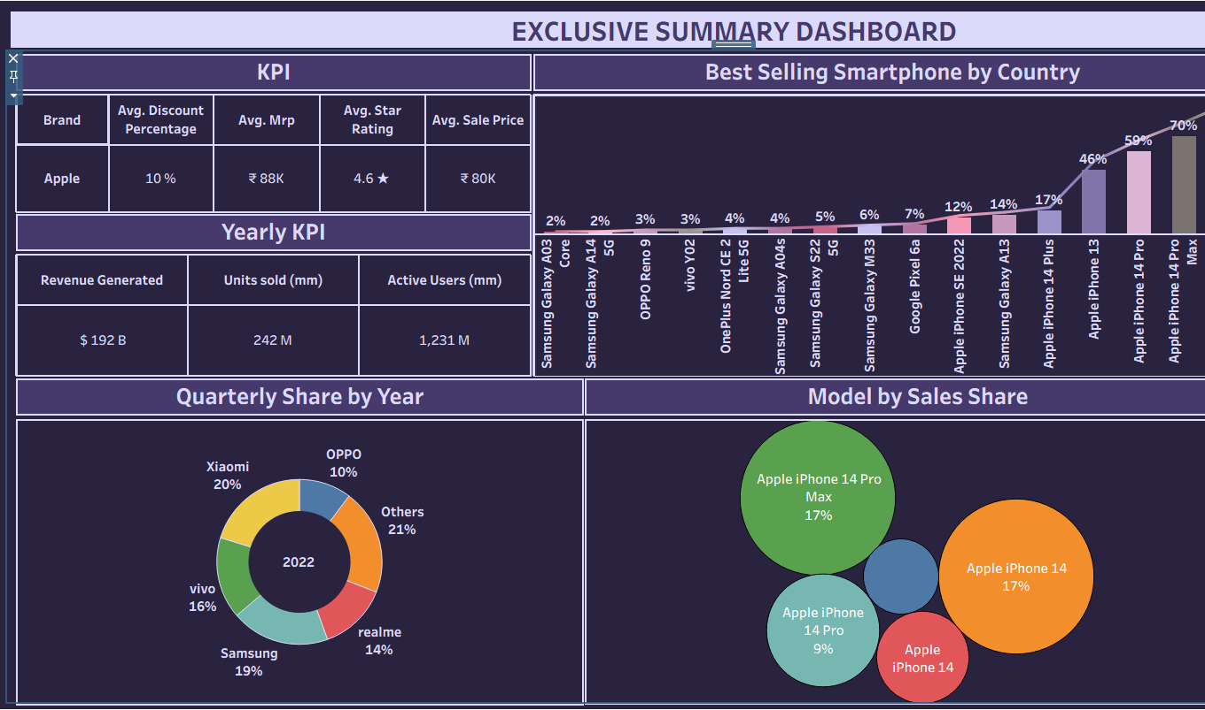
- Pricing comparison dashboard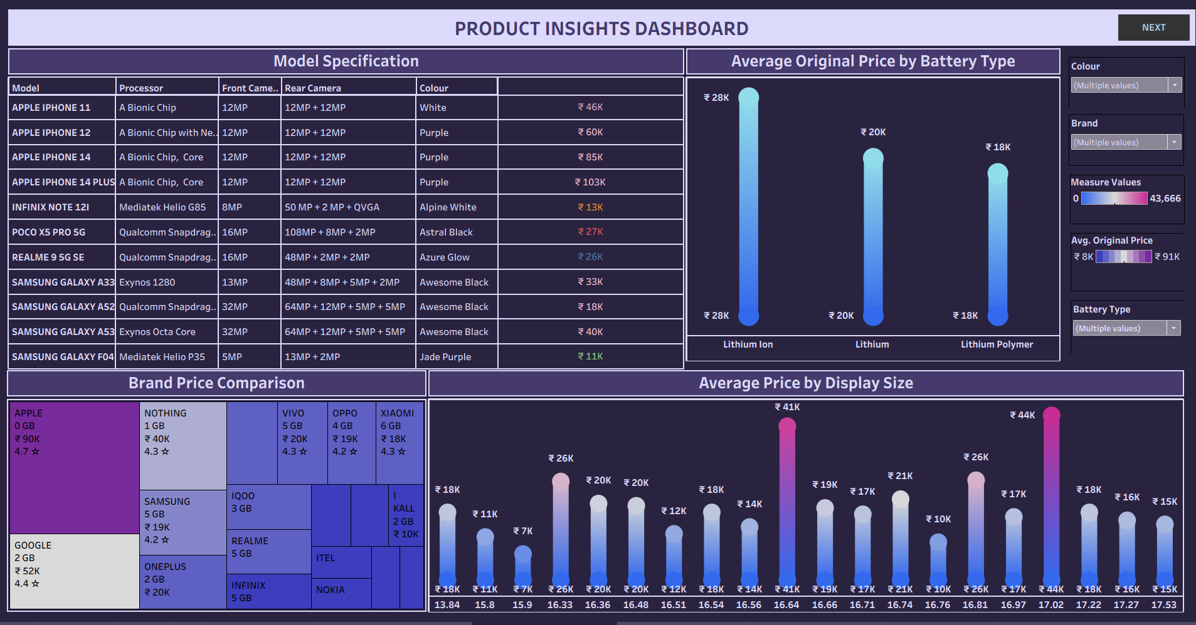
- Market share analysis dashboard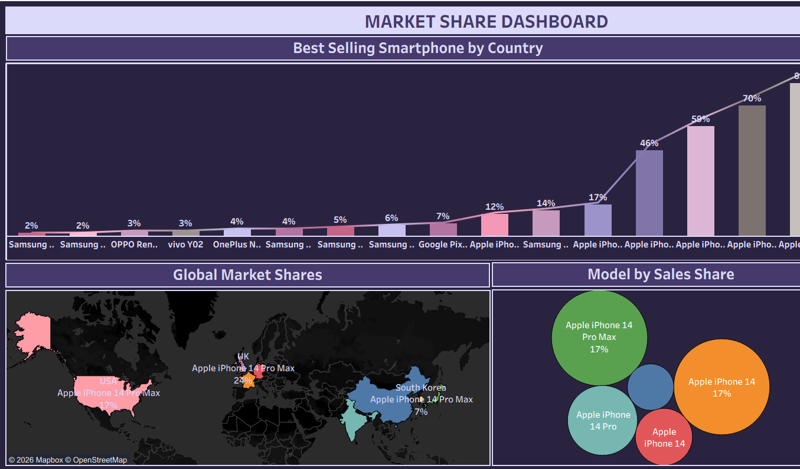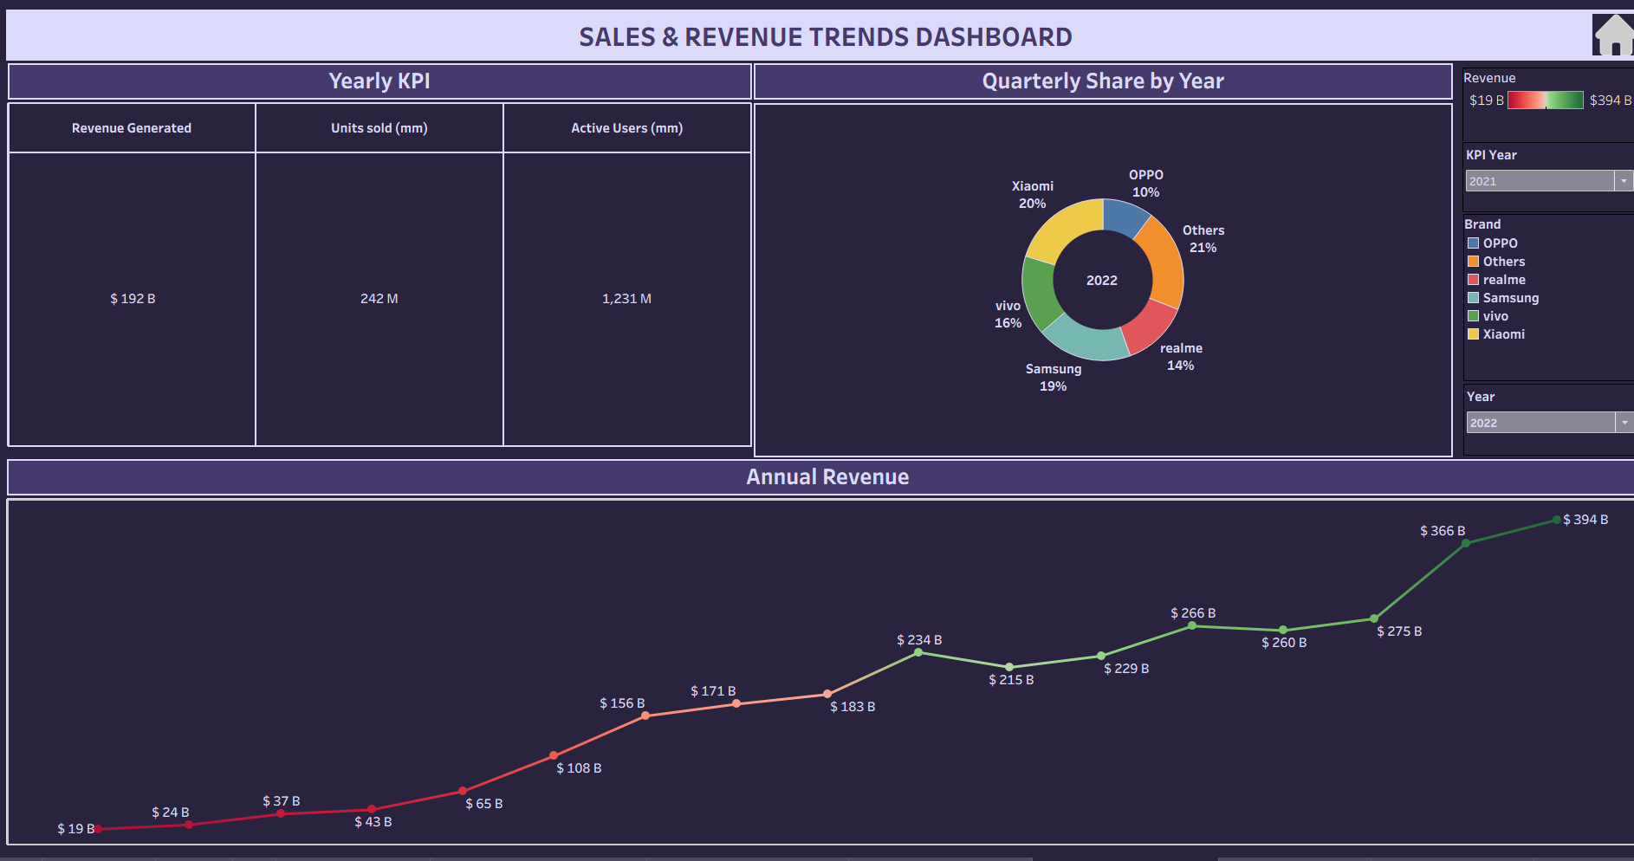

8. ADVANTAGES & DISADVANTAGES
Advantages
- Clear visual insights
- Interactive and user-friendly dashboards
- Faster decision-making
Disadvantages
- Dependent on data quality
- Limited to available datasets
- Requires Tableau knowledge

9. CONCLUSION
The iRevolution project successfully demonstrates how data visualization can simplify complex market data. By using Tableau, the project provides meaningful insights into the impact of iPhones in the Indian smartphone market, supporting informed decision-making.

10. FUTURE SCOPE
- Integration of real-time data
- Predictive analytics using machine learning
- Expansion to compare multiple smartphone brands

11. APPENDIX
- Dataset Link:
https://docs.google.com/spreadsheets/d/1p1ZWaYcEuFl5UNFcmNvpkXi3JnoHamut/edit?gid=1877446487#gid=1877446487
- GitHub & Project Demo Link: https://public.tableau.com/views/SmartbridgeProjectIREVOLUTION/ExclusiveSummaryDashboard?:language=en-US&publish=yes&:sid=&:redirect=auth&:display_count=n&:origin=viz_share_link

